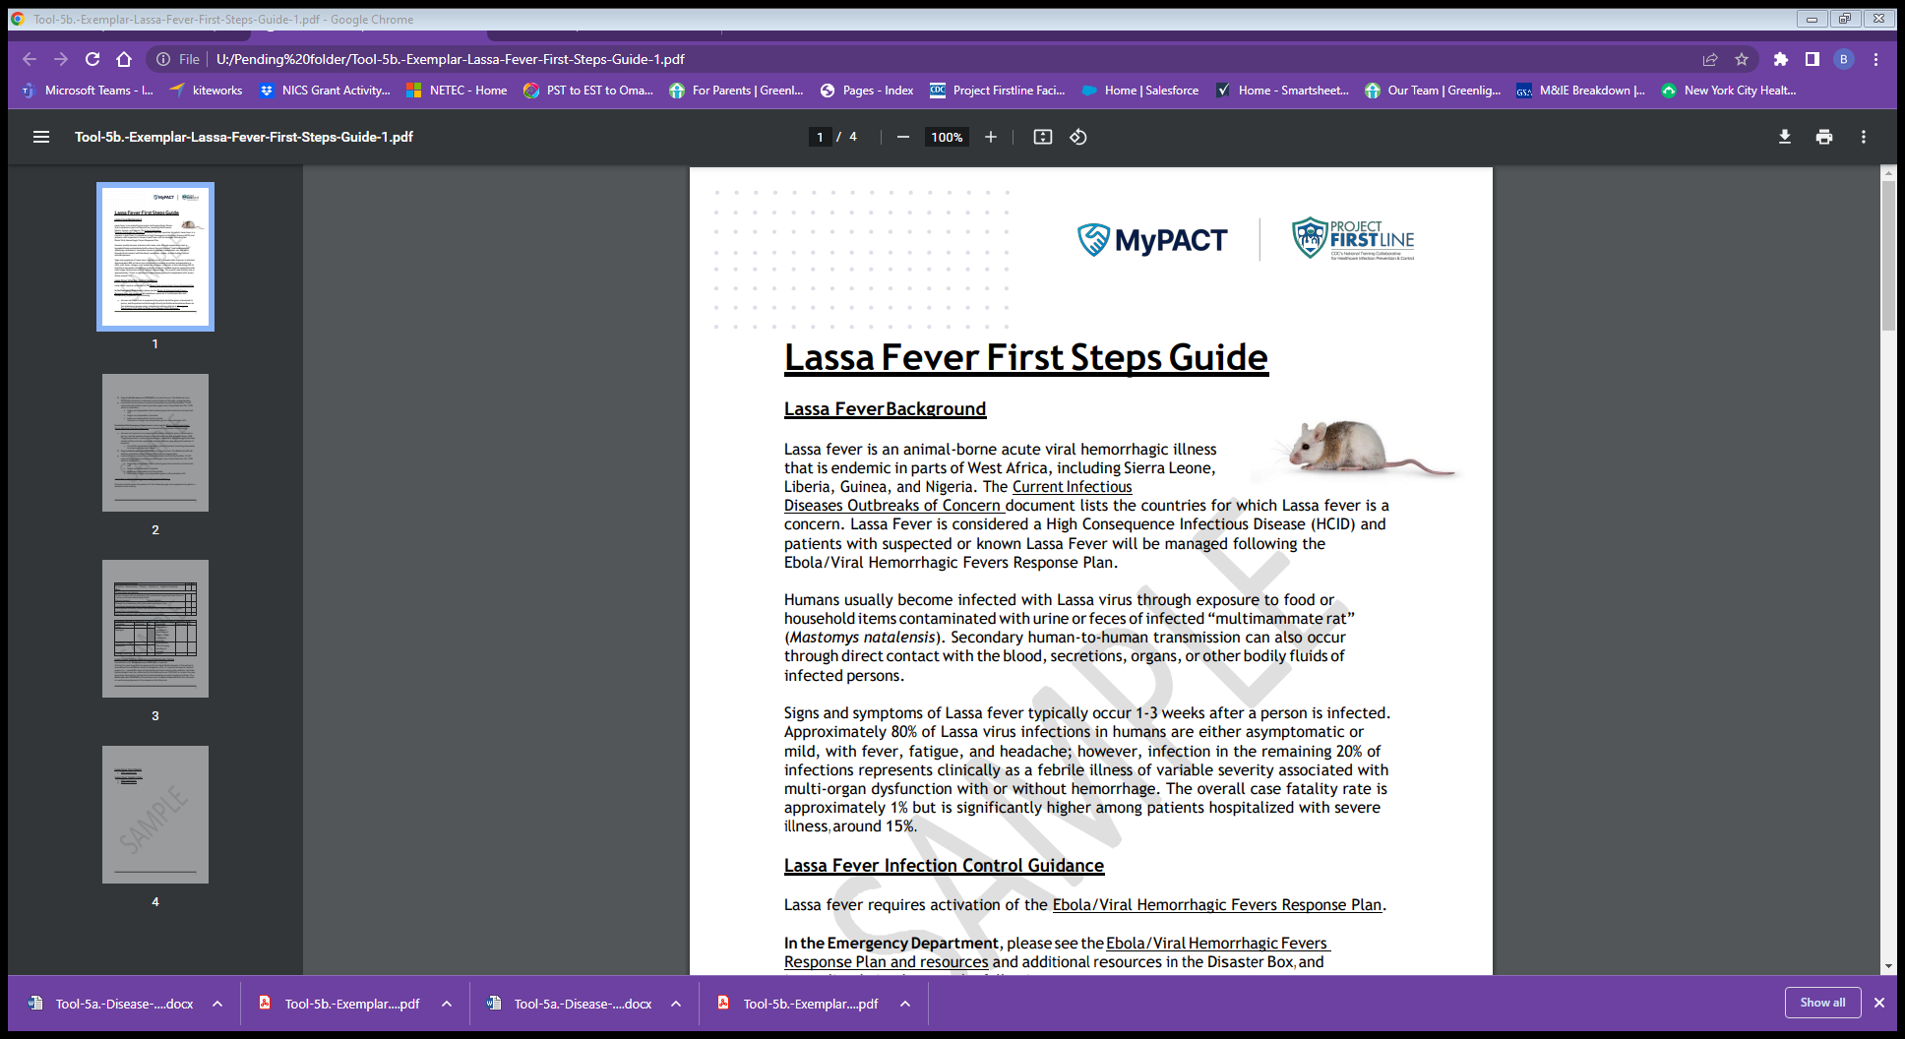  

**Special Pathogens Notification List**

**(**Put Facility Name Here**)**

Internal Contact

|  |  |  |  |  |  |
| --- | --- | --- | --- | --- | --- |
|  | **Name or Department** | **Role** | **Phone #** | **Alternate** | **Comments** |
| 1. | Facility Infection Prevention and Control  Department |  |  |  |  |
| 2. | Facility’s Hospital Epidemiologist or Infectious Disease  Consultation |  |  |  |  |
| 3. | Facility Leadership  (AOD, COO, CEO, CMO) |  |  |  |  |
| 4. | Local Leadership (e.g. Nurse Director,  Attending Physician) |  |  |  |  |
| 5. | Environmental Health  and Safety |  |  |  |  |

*Based on facility plans, consider activating Hospital Incident Command System or notifying key members of the leadership team.

External Contact

|  |  |  |  |  |
| --- | --- | --- | --- | --- |
|  | **Name or Department** | **Role** | **Phone #** | **Comments** |
| 1. | Local/State Department  of Health |  |  | Call to ascertain risk and if  meets PUI criteria |
| 2. | Centers for Disease Control & Prevention |  |  | Communication will likely be facilitated through local/state public health; however direct phone  number to CDC EOC. |